N+ Network Security
Network Threats and Mitigation & Physical Security and Risk

1. Create a table listing 5 common network threats (such as phishing, DDoS, man-in-the-middle, malware, and password attacks), and for each, write one real-world example from an app or service you use (like WhatsApp, Instagram, or Paytm).
=
Network Threat | Real-World Example
Phishing | A fake Paytm login page tries to steal your username and password.
DDoS (Distributed Denial of Service) | An Instagram service outage caused by attackers flooding its servers with traffic.
Man-in-the-Middle (MITM) | Using unsecured public Wi-Fi could allow an attacker to intercept data while you use WhatsApp.
Malware | Downloading a fake WhatsApp APK that installs malicious software on your phone.
Password Attack | Attackers use leaked passwords to try logging into your Instagram account (credential stuffing or brute force).

2. Simulate a brute-force attack scenario by writing a simple Python script that tries to guess a 4-digit PIN code by checking all possible combinations against a preset value.<br><br><em><strong>Constraint:</strong> The script should print the number of attempts it took to guess the correct PIN.</em>
= # Preset 4-digit PIN
correct_pin = "4827"

attempts = 0

# Try all possible 4-digit PINs (0000 to 9999)
for i in range(10000):
guess = f"{i:04d}" # Format as 4 digits (e.g., 0001)
attempts += 1

if guess == correct_pin:
print("PIN Found:", guess)
print("Number of attempts:", attempts)
break
3. List 4 physical security risks that could affect a server room hosting a popular app like Zomato or BookMyShow, and suggest one mitigation step for each risk.
=
Physical Security Risk | Mitigation Step
Unauthorized access to the server room | Use biometric or keycard access control and CCTV monitoring.
Fire | Install smoke detectors and automatic fire suppression systems.
Power outage | Use UPS systems and backup generators to keep servers running.
Overheating | Install proper air conditioning and monitor server room temperature continuously.

4. Draw a simple floor plan (hand-drawn or digital) of a small office and mark at least 3 physical security measures you would implement to protect network equipment (such as CCTV, biometric access, or cable locks).
= 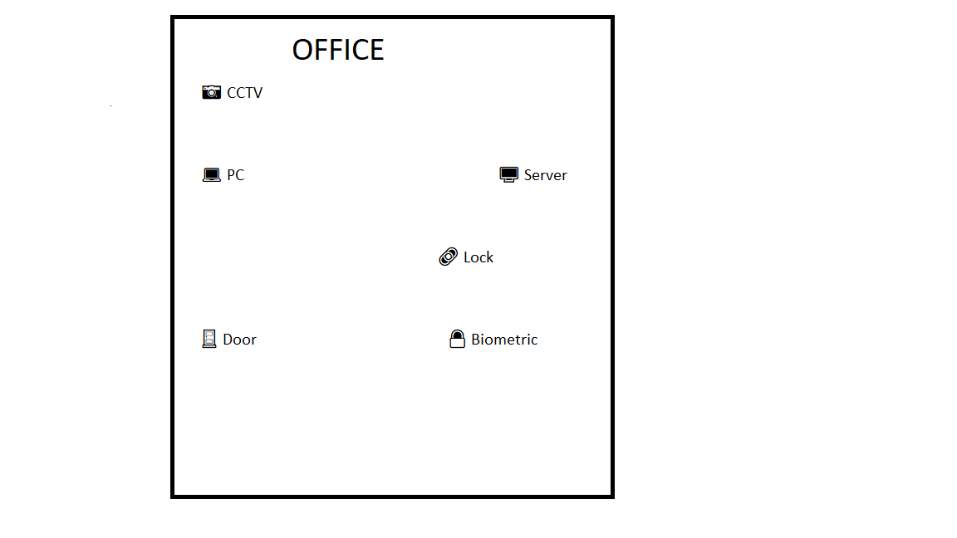
5. Use ChatGPT or a similar AI tool to generate a checklist of 7 actions a network admin should take to mitigate risks from both network threats and physical security breaches, then review and edit the checklist to make it specific for a college computer lab environment.
= College Computer Lab Security Checklist
- ✅ Use strong passwords.
- ✅ Keep computers updated.
- ✅ Turn on the firewall.
- ✅ Install antivirus software.
- ✅ Lock the server room.
- ✅ Use CCTV cameras.
- ✅ Lock network devices and back up important data regularly.

